German Credit Risk
Nayantara Ravi Samtani
BUSI 4016FA/FDE Data Mining & Predictive Analytics

08-10-2025

Section A - Defining the Problem

Credit agencies are in the business model of taking capital and distributing loans to different customers to earn interest. HoIver in this business credit agencies run the risk of creditors defaulting on their loans which results in significant losses for the agency. For these reasons credit agencies collect data on the loan applicants to help predict which customers are likely to default on loans. This data aids in the decision of if loan applicants should be accepted or denied.

The primary stakeholder is a credit or financial institution as they will benefit from this information, as they will have a better prediction on whether someone will default on their loan. This will help them determine an appropriate interest rate that relates to the riskiness of the applicant.

They will use the model’s predictions for several things. First of all, to assess the loan applications more efficiently and objectively without basing their judgment only on reputation as it was the case in the past. Then, it will help them reduce default risk by identifying potentially unreliable borroIrs. Last, this analysis will support the decision-making by supplementing or partially automating credit approval processes. This will help remove human bias and error from the loan approval process.

Thus, those who will be affected first are the loan applicants, as their approval or denial decisions will be influenced by the model’s output. In addition, the credit analysts, managers and agencies will be affected positively as this method will be more efficient and reliable than human judgement. This will increase the profitability of the credit agencies particularly as the cost of accepting bad clients is large.

The model will take the data provided to the bank and make a prediction on whether the loan application should be approved. This analysis will consider that it is much worse to classify poor clients as good clients then vice versa, as defaults are very costly to the credit agencies.

Once a model is chosen it will continue to be used and updated continually. The model’s performance must be continuously monitored and updated as economic conditions such as inflation, political unrest. Additionally customer behaviors, or even credit policies change overtime. To ensure that predictions remain valid and fair over time, regular training and validation will be used.

Section B - Data and Methods
Data cleaning and preparation
The data I am going to use is 1000 instances of a credit application and whether it was a good or bad credit. The data was acquired from the UC Irvine Machine Learning Repository (Hofmann, 1994). The data has 1000 records which is a reasonable amount for I analysis. The records contain 31 different parameters, based on personal information, family status, current assets, other credits, and employment. This data is complete, as it has the essentials for telling whether someone should be approved or not. This data also did not contain any missing values.

I first step was to convert the data from a .data file to a .csv file using Microsoft Excel’s import data feature.
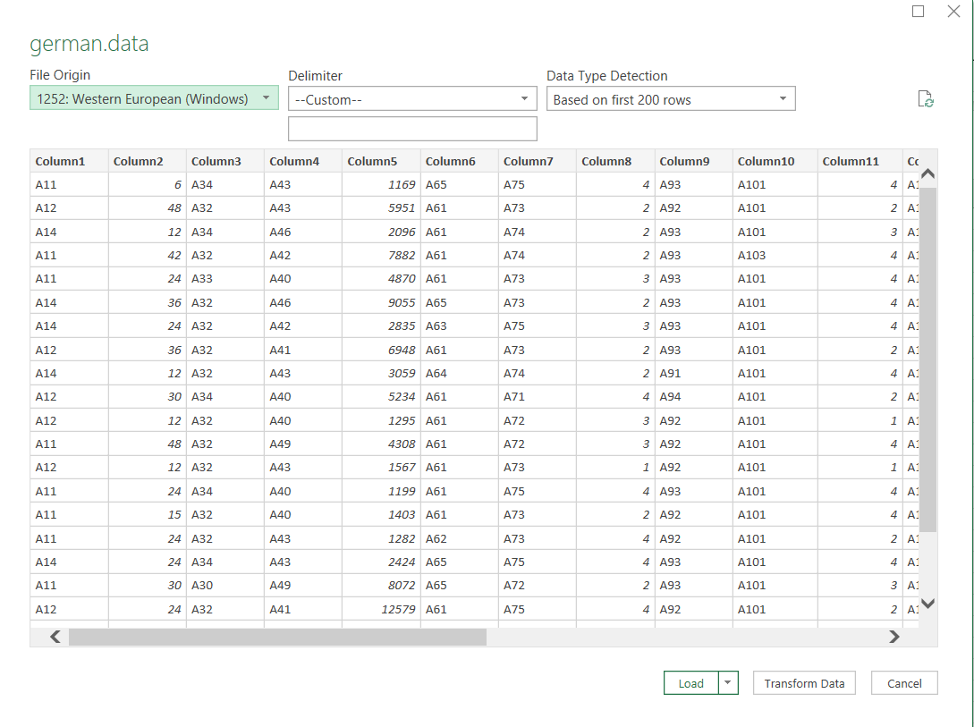
Two problems still needed to be solved. The first was the many categorical variables. These are a problem as the machine learning techniques do not work with categorical data. This would require the use of dummy variables. The second problem is that after creating dummy variables, I had a total of 62 columns, which is too many for analysis. If I used analysis with 62 columns it would have likely led to overfitting. The string of nodes below was I methodology to prepare the data for machine learning by turning categorical data into dummy variables, and using a PCA analysis to reduce the number of columns.
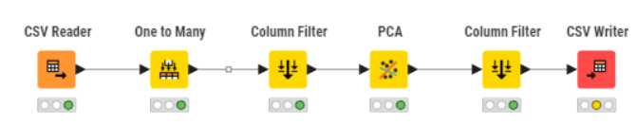For data preparation I needed to start with converting categorical data into dummy variables. This was done in KNIME using the One to Many node. 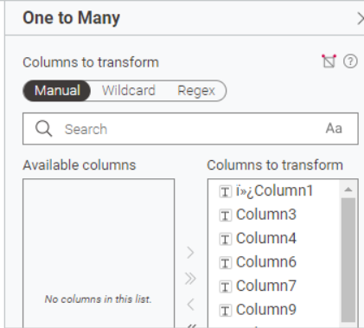
Next the Column Filter node was used to remove all the existing categorical data.
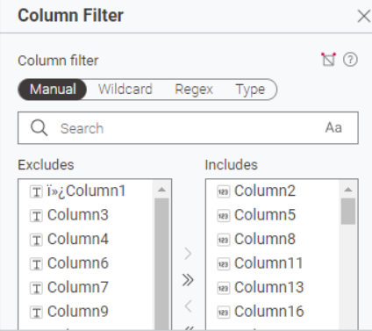
Next a PCA analysis was conducted. For this only the output (Column 21 shown below) was removed from the analysis. I chose to reduce it down to five dimensions.
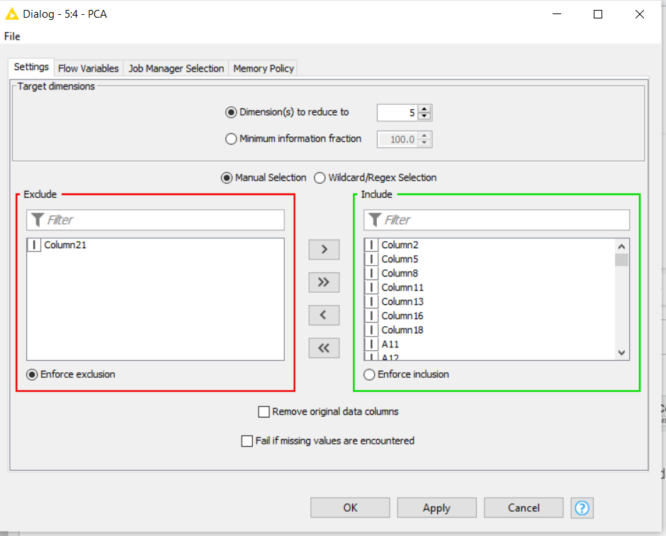
After that a Column filter was used to remove all the original variables used in the PCA analysis. Then a new CSV file was created with the CSV writer node.
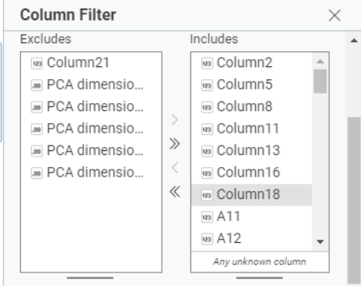

Data analytics
Models used
Since the goal of this project is to classify future applicants into good or bad credit risk categories, I selected supervised machine learning techniques that are appropriate for binary classification problems. As mentioned earlier, three models Ire considered: Logistic Regression, Decision Tree, and Neural Network and each approach offers unique strengths. Logistic regression provides interpretability and probability estimates, decision trees capture non-linear relationships and are easy to explain to stakeholders, and neural networks have the capacity to detect complex patterns.

Software Choice
Choosing the appropriate analytical platform for implementation was crucial to I process. After considering multiple tools including such as JMP, SAS, and Python, I selected KNIME as the primary environment for model development, evaluation, and deployment.

First, KNIME provides a visual, node-based workflow interface that makes it possible to trace every step of the machine learning process, from preprocessing and PCA dimension reduction through modeling and scoring. This allowed transparency which is critical in the credit risk domain where traceability and explainability are necessary. Unlike JMP, which is better suited for exploratory statistical modeling and manual experimentation, KNIME offers a repeatable pipeline structure that aligns with real-world production deployment and version control practices.

Additionally, KNIME supports a broad range of machine learning algorithms out-of-the-box and integrates natively with both Python and R when needed, giving flexibility as model demands grow. Compared to SAS, which is poIrful but less for prototyping environments, KNIME is more viable for iterative experimentation and collaboration. Meanwhile, although Python offers extensive flexibility through libraries it requires more complex coding and higher computational management. In contrast, KNIME’s low-code interface alloId us to focus more on model logic, performance, and interpretability rather than debugging implementation code. Finally, KNIME provides integrated tools for performance measurement (confusion matrices, accuracy scores, ROC analysis) that allows consistent evaluation across all algorithms using identical data partitions. Hence, KNIME was chosen as the platform best suited for developing and comparing the machine learning models used in this credit risk classification project.

Logistic Regression
Below are the nodes in KNIME to create the logistic regression
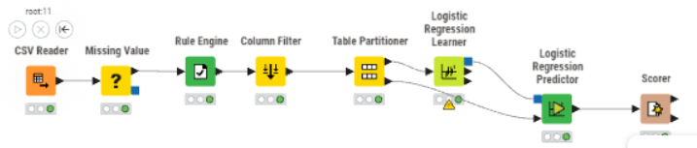
Firstly the data was acquired using the CSV Reader Node. Then the missing values Ire removed with the missing value node. After that the Rule Engine node was used to define which records are classified as “good” or “bad” for the algorithm.
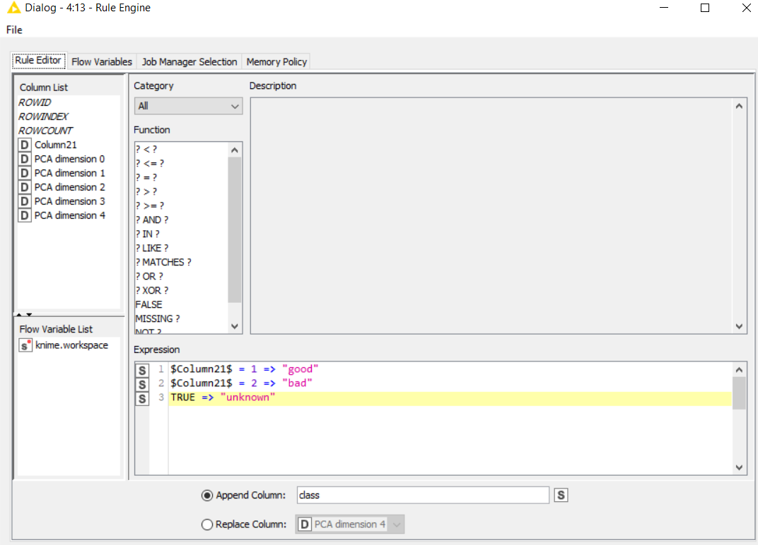
Next the dataset was divided into a 70% training set and a 30% holdout validation set, allowing us to train models on one portion of the data and then evaluate their generalization ability on applicants. This separation is critical in credit risk modeling to avoid overfitting and ensure that the model can reliably predict real future cases rather than memorizing patterns from historical records.
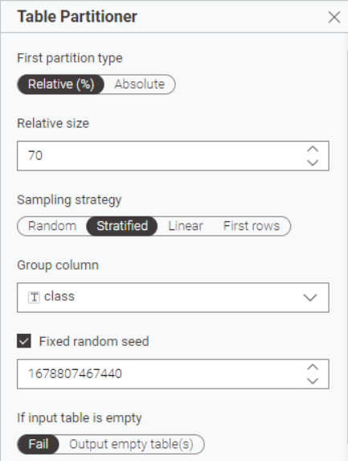
Next the Logistic Regression Leaner node was used to train the model.
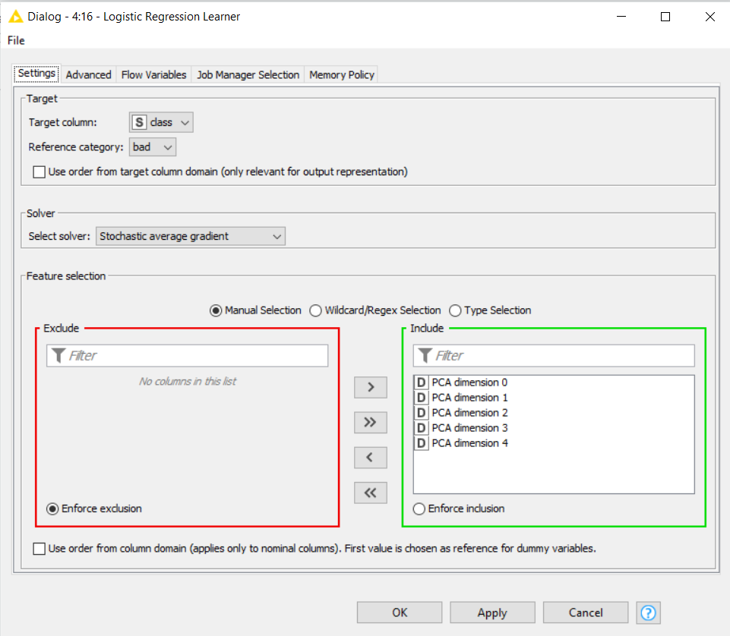
Then the logistic Regression Predictor node was used to test the validation data, and the Scorer node was used to display the results.
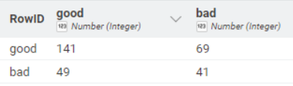
Neural Network
Below are the nodes in KNIME to create the neural network
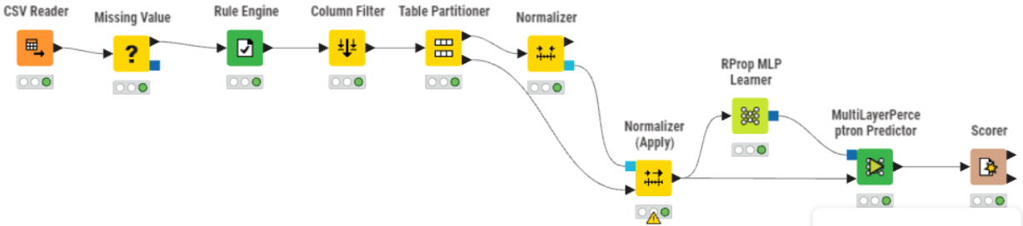
Firstly the data was acquired using the CSV Reader Node. Then the missing values Ire removed with the missing value node. After that the Rule Engine node was used to define which records are classified as “good” or “bad” for the algorithm.
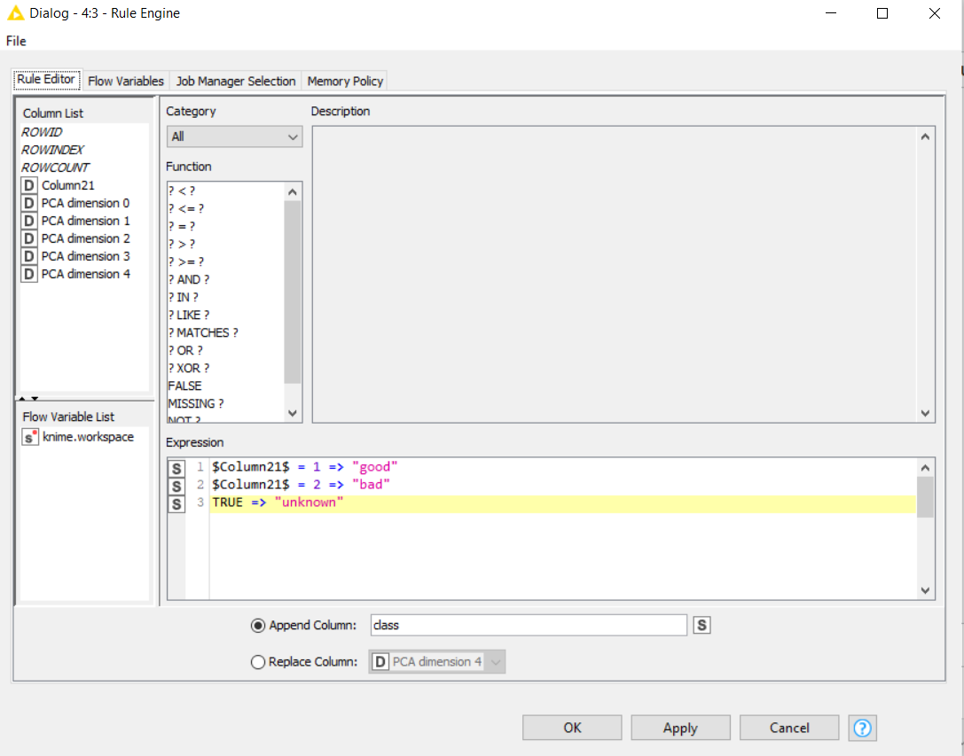
Next the dataset was divided into a 70% training set and a 30% holdout validation set, allowing us to train models on one portion of the data and then evaluate their generalization ability on applicants. This separation is critical in credit risk modeling to avoid overfitting and ensure that the model can reliably predict real future cases rather than memorizing patterns from historical records.

Next I used the Normalizer node and the Normalizer Apply nodes to normalize the data.
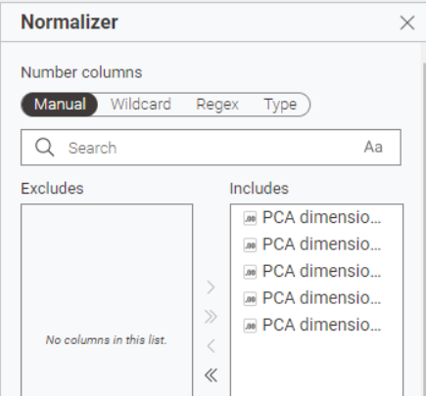
Next the RProp MLP Learner node was used to train the model. Only 1 hidden layer was used to prevent overfitting the data.
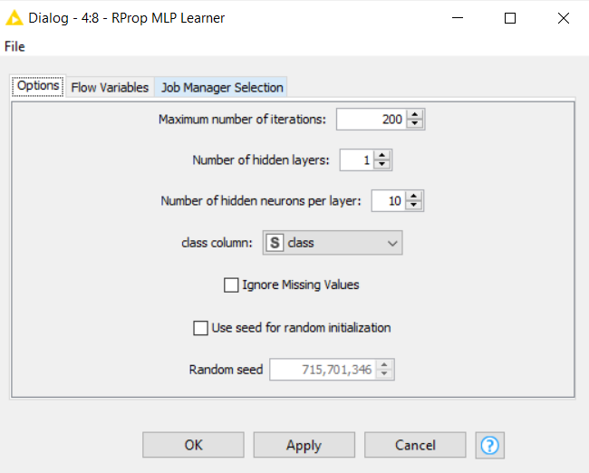
Then the MultiLayerPerceptron Predictor node was used to test the validation data, and the Scorer node was used to display the results.
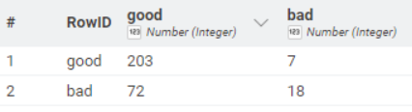

Decision Tree
Below are the nodes in KNIME to create the decision tree.
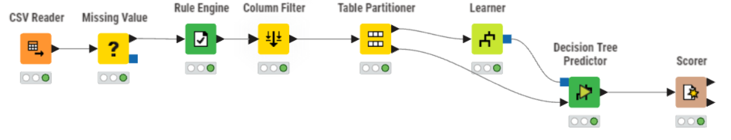
Firstly the data was acquired using the CSV Reader Node. Then the missing values Ire removed with the missing value node. After that the Rule Engine node was used to define which records are classified as “good” or “bad” for the algorithm.
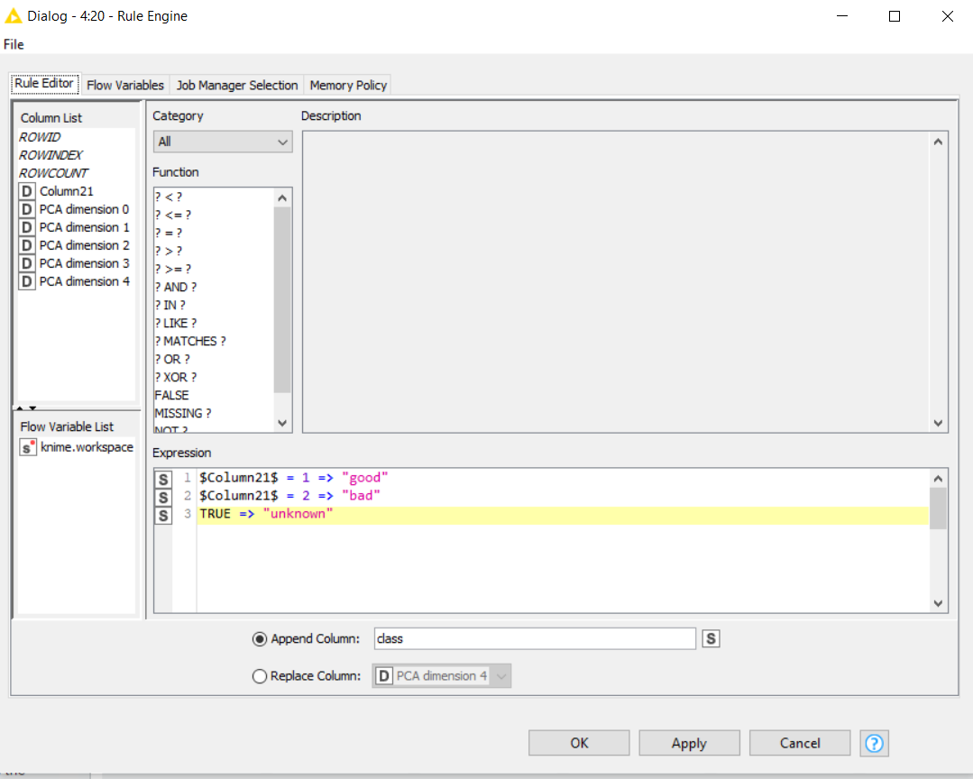
Next the dataset was divided into a 70% training set and a 30% holdout validation set, allowing us to train models on one portion of the data and then evaluate their generalization ability on applicants. This separation is critical in credit risk modeling to avoid overfitting and ensure that the model can reliably predict real future cases rather than memorizing patterns from historical records.

Next the Decision Tree node was used to train the model. The Gini index was chosen as the quality measure to achieve the maximum homogeneity in each of the regions. Additionally a minimum of 20 records per node was used to prune the tree and ensure that it was not overfitting the data.
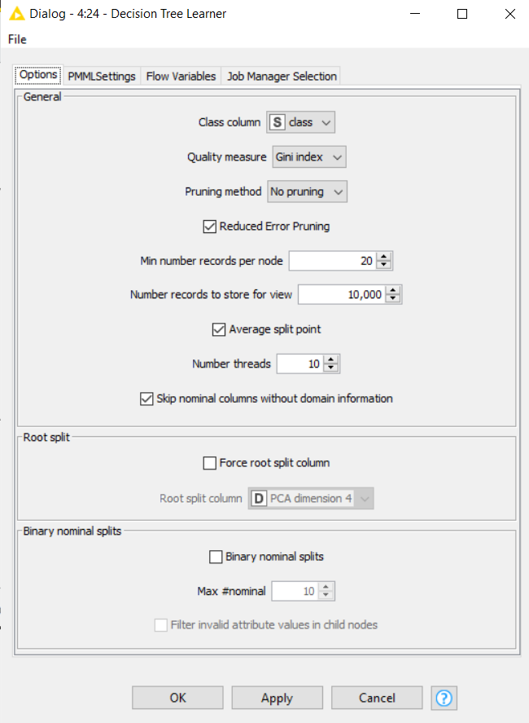
The decision tree generated is shown below
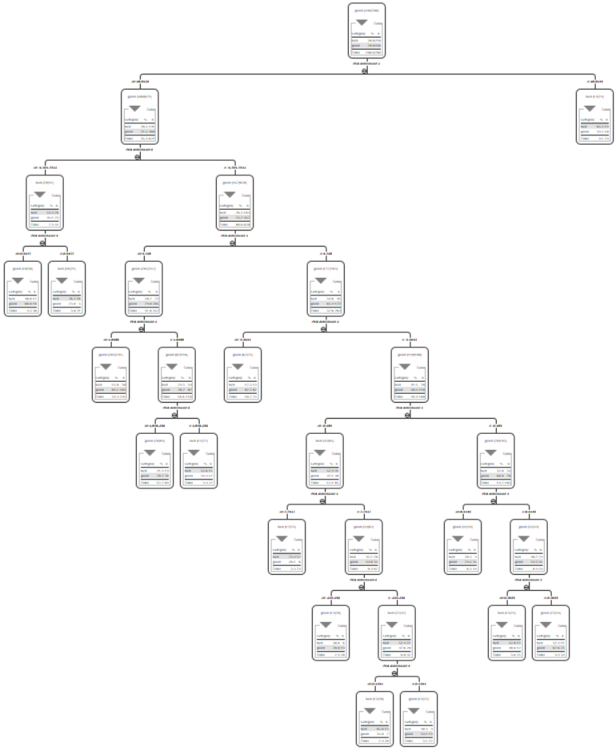
The first few branches of the tree are as follows:
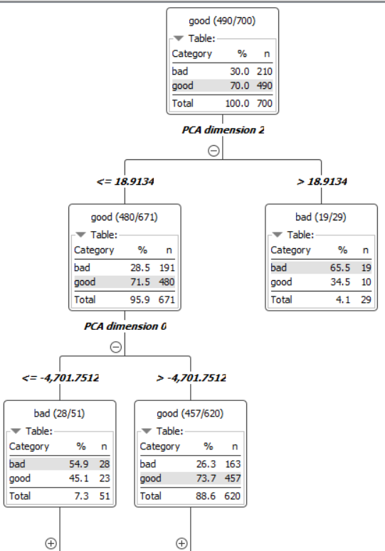

Then the Decision tree predictor node was used to test the validation data, and the Scorer node was used to display the results.
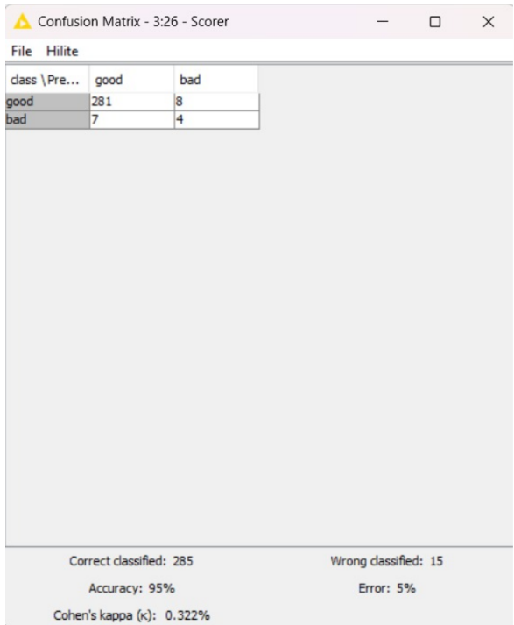

In the end, I selected the Decision Tree classifier as the final model due to its strong performance and its interpretability, which is essential in credit risk evaluation where transparency is strongly valued by both regulators and business users.

Section C - Modeling, Outcomes & Evaluation

Model Development
Once the data preprocessing and PCA Ire completed, I began building I machine learning models. The dataset was split into a 70% training set and a 30% holdout set, allowing us to train the models on one portion of the data and then evaluate them on completely unseen records. The PCA transformation reduced I original set of 62 dummy variables to five principal components, which captured most of the information while reducing noise and complexity.
Using these components as inputs, I trained three supervised learning models in KNIME: logistic regression, a decision tree, and a simple neural network. These models Ire chosen because they represent different types of learning approaches—linear, rule-based, and non-linear—and therefore alloId us to compare different strengths. After experimenting with all three, the decision tree emerged as the most suitable model for I specific business problem. It performed very Ill in terms of predictive accuracy, and it has the added advantage of being highly interpretable, which is important for credit scoring systems that require transparency.

Model Outcomes
The final decision tree was evaluated on the 300-record holdout dataset, and its performance is summarized in the confusion matrix generated by KNIME:
Actual \ Predicted | Good | Bad
Good | 281 | 8
Bad | 7 | 4
The model correctly classified 285 applicants and misclassified 15, which corresponds to an accuracy of 95% and an error rate of 5%. Because the dataset is imbalanced, with many more good applicants than bad ones, I also looked at Cohen’s Kappa, which was 0.322. This statistic adjusts for the impact of class imbalance and shows that the model performs significantly better than chance, even though the minority class remains more difficult to detect.
A deeper look at the matrix reveals that the tree performs extremely Ill at identifying good applicants, correctly classifying 281 out of 289 (a specificity of 97.2%). HoIver, it is less accurate when detecting bad applicants. Only 4 out of 11 bad cases Ire correctly identified, giving a sensitivity of about 36%. This means that although the overall accuracy is high, the model tends to classify ambiguous cases as good rather than bad.

Interpretation and Evaluation
The strong overall performance of the decision tree suggests that it learned recognizable patterns in the credit applicant data. With 95% accuracy, the model is able to classify most loan applications correctly, which is impressive given the complexity of the dataset. HoIver, accuracy alone does not capture the entire picture, especially since the dataset contains far feIr bad applicants. In such cases, a model can appear to perform Ill simply by predicting the majority class.
The model’s excellent ability to identify reliable borroIrs has clear advantages for a credit institution. It reduces the likelihood of rejecting good applicants, which could harm customer relationships and reduce potential revenue. At the same time, the loIr sensitivity for detecting bad applicants means that the model may incorrectly approve some individuals who pose a higher risk of defaulting. In I evaluation, this occurred seven times in the holdout dataset, which is notable because these errors can be financially costly.
Even though the decision tree has its limitations, it remains a strong and practical model for an initial screening system. Its interpretability allows analysts to understand why a particular decision was made, and it provides a solid foundation that can be improved in future iterations. For example, techniques such as rebalancing the dataset, applying cost-sensitive learning, or incorporating ensemble models could help reduce the number of false approvals.
Overall, the model demonstrates strong performance and delivers useful insights, but its limitations regarding minority-class detection suggest that additional safeguards or adjustments would be beneficial when the model is deployed in a real credit-scoring environment.

References

Hofmann, H. (1994). Statlog (German Credit Data) [Dataset]. UCI Machine Learning Repository. https://doi.org/10.24432/C5NC77.

